Dokumentasi Project Computer Vision – Gender Classification

Project ini merupakan program untuk mendeteksi jenis kelamin berdasarkan wajah manusia. Data training berasal dari beberapa foto pria dan wanita yang kami dapatkan dari internet.

Hasil output Program:

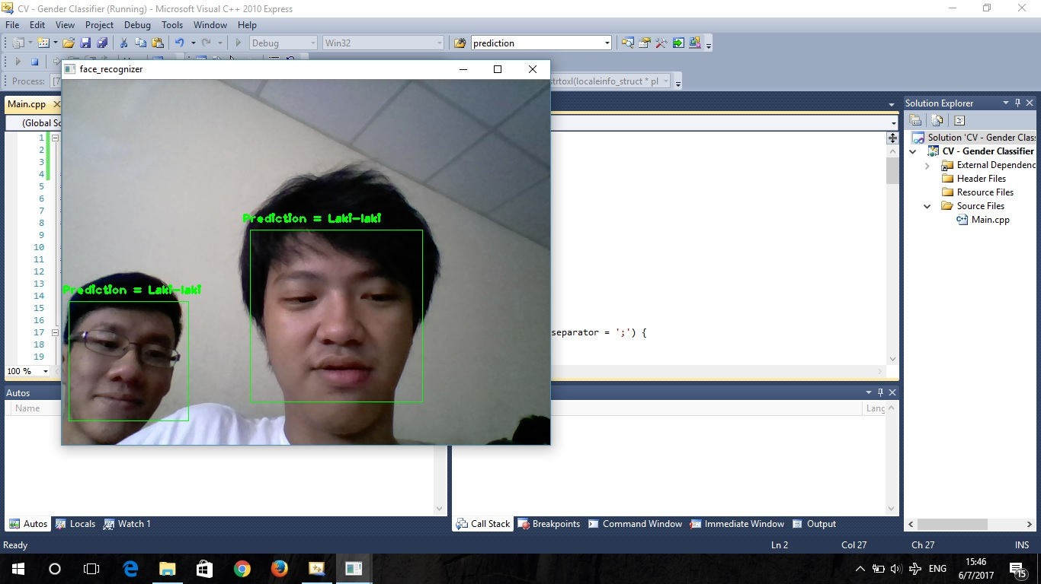

Source Code:

//Giovanno Sebastian 1901456905

//Robby Pranata 1901460474

#include "opencv2/core/core.hpp"

#include "opencv2/contrib/contrib.hpp"

#include "opencv2/highgui/highgui.hpp"

#include "opencv2/imgproc/imgproc.hpp"

#include "opencv2/objdetect/objdetect.hpp"

#include <iostream>

#include <fstream>

#include <sstream>

using namespace cv;

using namespace std;

static void read_csv(const string& filename, vector<Mat>& images, vector<int>& labels, char separator = ';') {

std::ifstream file(filename.c_str(), ifstream::in);

if (!file) {

string error_message = "No valid input file was given, please check the given filename.";

CV_Error(CV_StsBadArg, error_message);

}

string line, path, classlabel;

while (getline(file, line)) {

stringstream liness(line);

getline(liness, path, separator);

getline(liness, classlabel);

if(!path.empty() && !classlabel.empty()) {

images.push_back(imread(path, 0));

labels.push_back(atoi(classlabel.c_str()));

}

}

}

int main() {

// Get the path to your CSV:

string fn_haar = "haarcascade_frontalface_alt.xml";

string fn_csv = "photo.csv";

int deviceId = 0;

vector<Mat> images;

vector<int> labels;

try {

read_csv(fn_csv, images, labels);

} catch (cv::Exception& e) {

cerr << "Error opening file \"" << fn_csv << "\". Reason: " << e.msg << endl;

exit(1);

}

int im_width = images[0].cols;

int im_height = images[0].rows;

// Create a FaceRecognizer and train it on the given images:

Ptr<FaceRecognizer> model = createFisherFaceRecognizer();

model->train(images, labels);

CascadeClassifier haar_cascade;

haar_cascade.load(fn_haar);

// Get a handle to the Video device:

VideoCapture cap(deviceId);

if(!cap.isOpened()) {

cerr << "Capture Device ID " << deviceId << "cannot be opened." << endl;

return -1;

}

// Holds the current frame from the Video device:

Mat frame;

for(;;) {

cap >> frame;

// Clone the current frame:

Mat original = frame.clone();

// Convert the current frame to grayscale:

Mat gray;

cvtColor(original, gray, CV_BGR2GRAY);

// Find the faces in the frame:

vector< Rect_<int> > faces;

haar_cascade.detectMultiScale(gray, faces);

for(int i = 0; i < faces.size(); i++) {

// Process face by face:

Rect face_i = faces[i];

// Crop the face from the image. So simple with OpenCV C++:

Mat face = gray(face_i);

// Resizing the face is necessary for Eigenfaces and Fisherfaces.

Mat face_resized;

cv::resize(face, face_resized, Size(im_width, im_height), 1.0, 1.0, INTER_CUBIC);

int prediction = model->predict(face_resized);

rectangle(original, face_i, CV_RGB(0, 255,0), 1);

// Create the text we will annotate the box with:

char gender[20];

//validate that 0 is female and 1 is male

if(prediction==0) strcpy(gender, "Perempuan");

else if(prediction==1) strcpy(gender, "Laki-laki");

string box_text = format("Prediction = %s", gender);

int pos_x = std::max(face_i.tl().x - 10, 0);

int pos_y = std::max(face_i.tl().y - 10, 0);

putText(original, box_text, Point(pos_x, pos_y), FONT_HERSHEY_PLAIN, 1.0, CV_RGB(0,255,0), 2.0);

}

imshow("face_recognizer", original);

char key = (char) waitKey(20);

//esc

if(key == 27)

break;

}

return 0;

}